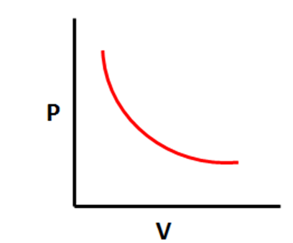
Boyle’s Law – Boyle investigated the relationship between the volume of a gas and the pressure exerted by that gas. He found that the data he collected consistently made the lines shown on the two graphs on the right.

SEE, THINK WONDER
What I SEE in the graphs | What I THINK the graphs show | What I WONDER about the graphs

